Sony a7iv Camera Profiles
The table below shows common abbreviations for the Sony a7iv Camera
Code | Description
Adobe
Standard
BW | For shooting images in black and white monotone
FL | Creates an image with moody finish by applying sharp contrast to the calm coloring as well as the impressive sky and colors of the greens
IN | Creates an image with matte textures by suppressing the contrast and saturation
NT | The saturation and sharpness are lowered for shooting images in subdued tones. This is also suitable for capturing image material to be modified with a computer
PT | For capturing skin in a soft tone, ideally suited for shooting portraits
SH | Creates an image with bright, transparent, soft and vivid mood
ST | Standard finish for a wide range of subjects and scenes
W | The saturation and contrast are heightened for shooting striking images of colorful scenes and subjects such as flowers, spring greenery, blue sky or ocean views
W2 | Creates an image with bright and vivid colors with rich clarity
SE | For shooting images in sepia monotone
 | Add Custom DCP
 | Add DCP from DNG
 | Set as Default for This Camera

Camera Profile for Sony a7iv ARW in Luminar Neo
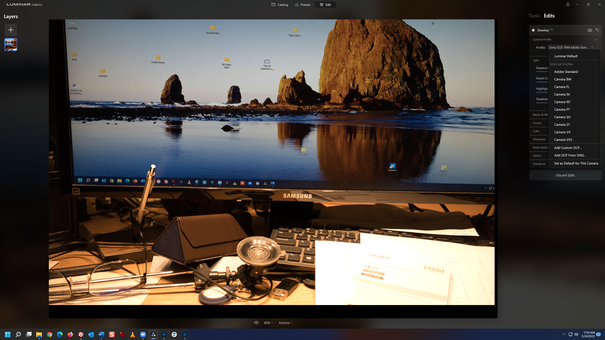

Camera Profile for Sony a7iv ARW in Adobe Photoshop Elements 2022
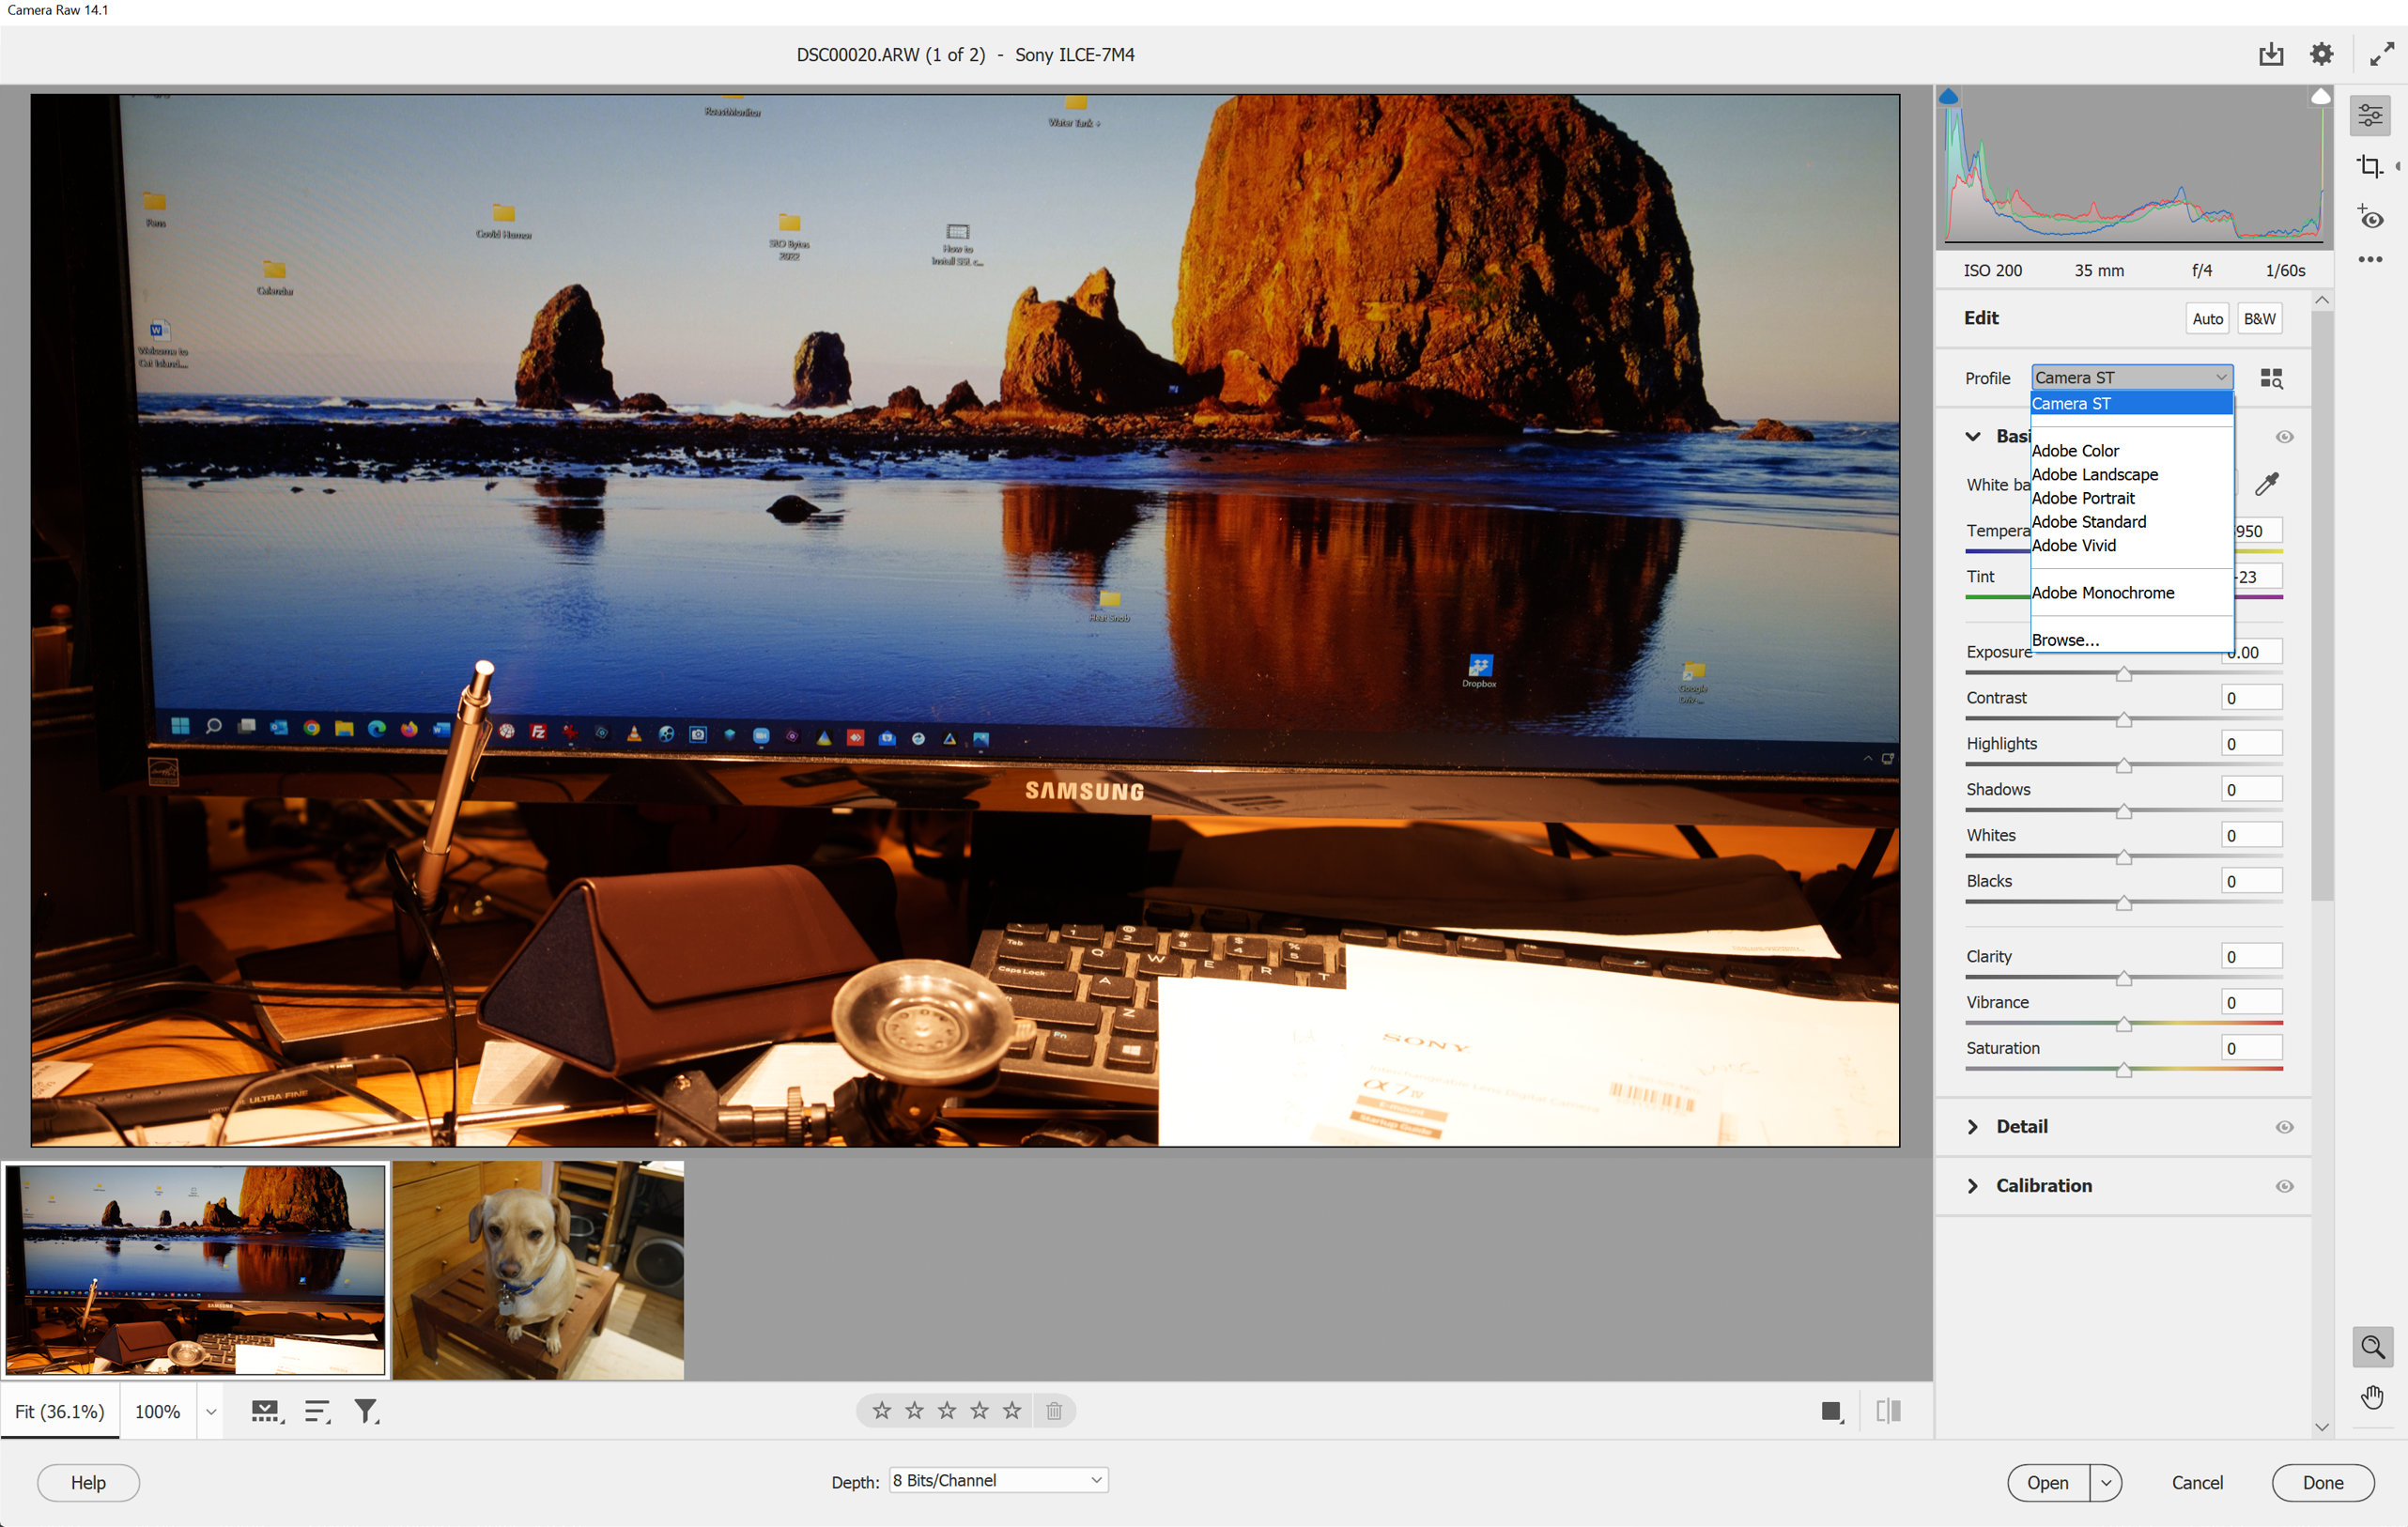
Camera Profile for a Panasonic DMC G7 RW2 in Luminar Neo
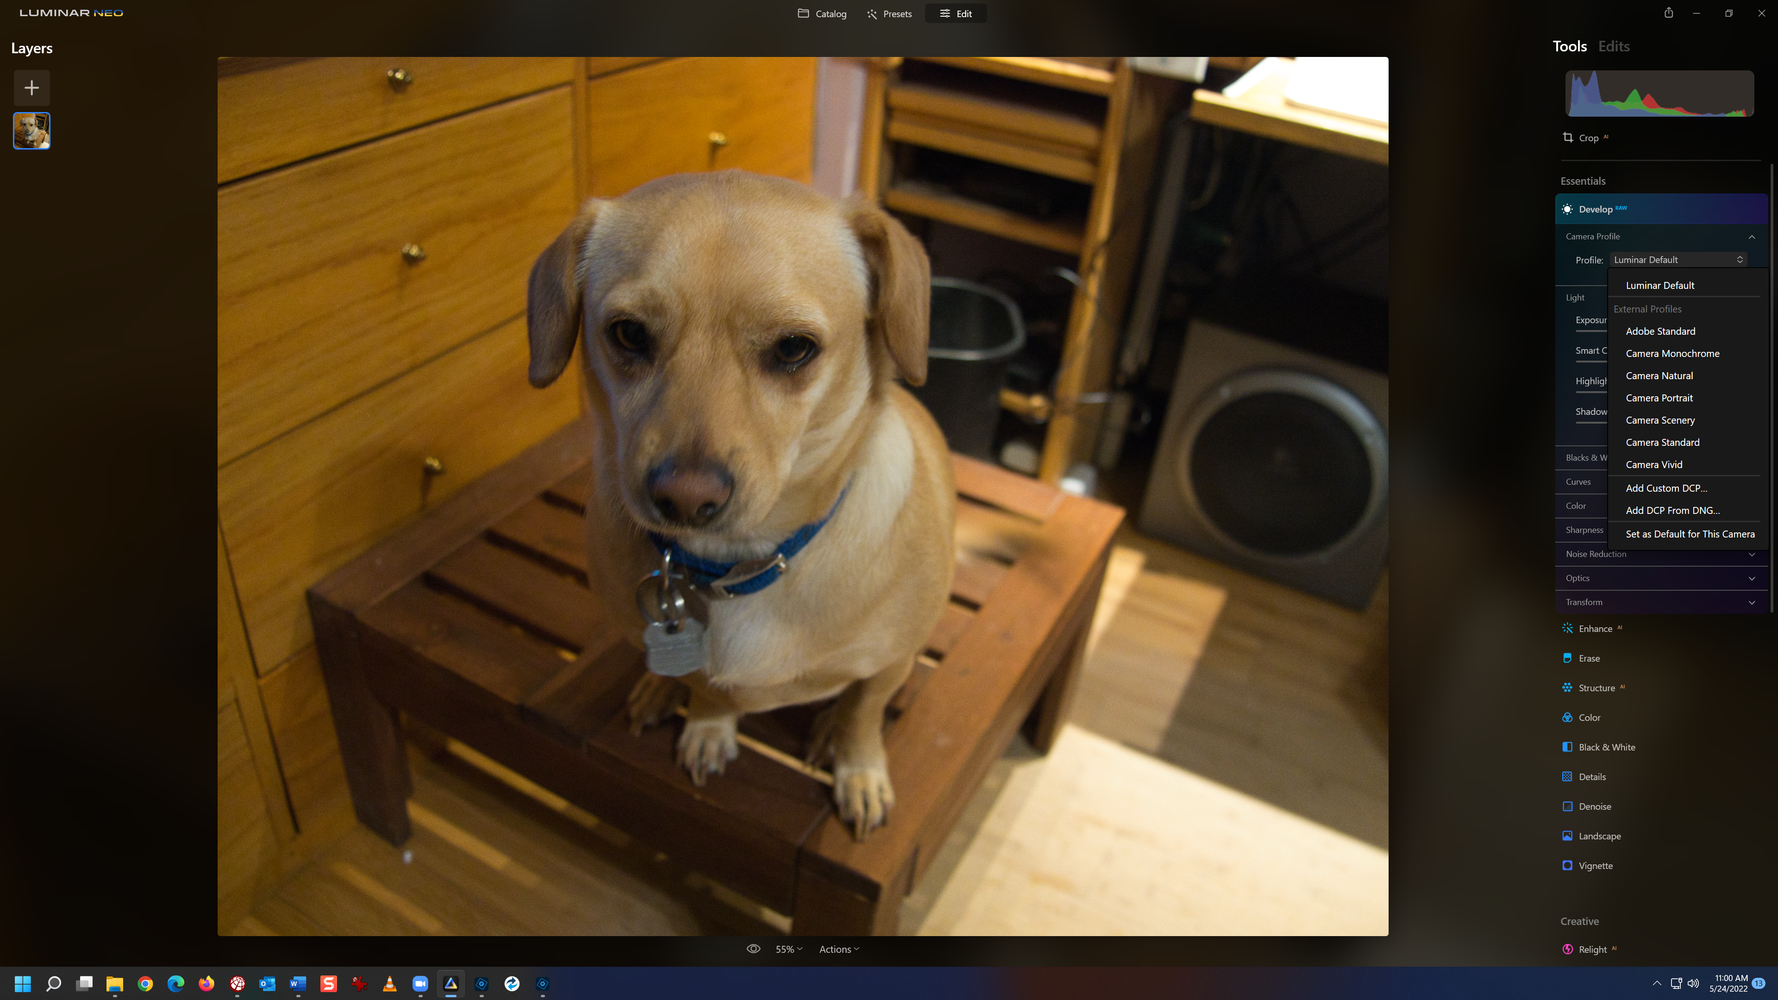

Camera Profile for a Panasonic DMC G7 RW2 in Adobe Photoshop Elements 2022
